Nginx

1 Install nginx and run nginx on port number 81.
I login in to the ec2
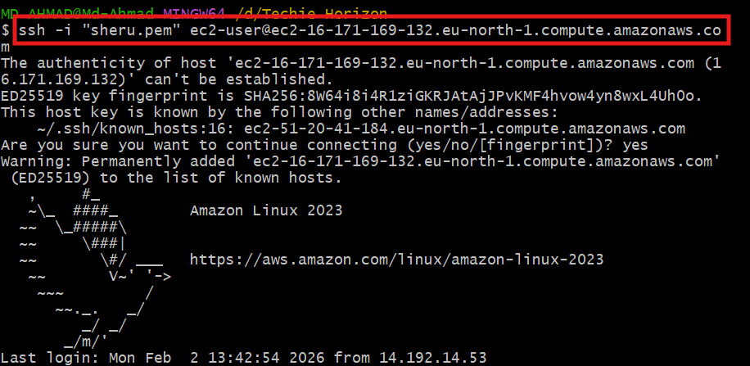
Update the packages

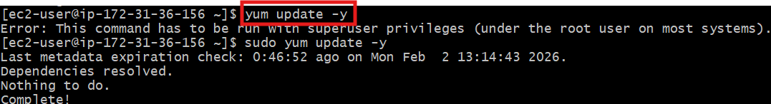
Install The nginx
After that is see the status of that
It is in inactive
After that I start nginx
After that I see the status of it
It is active status

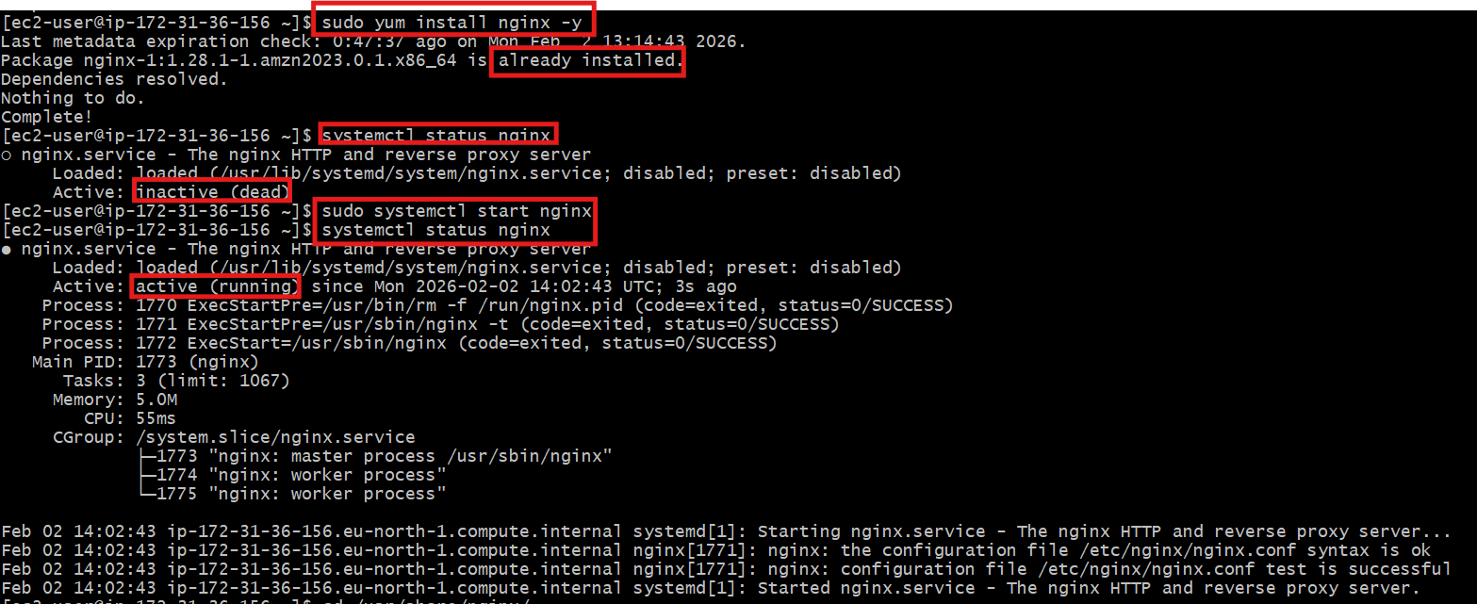
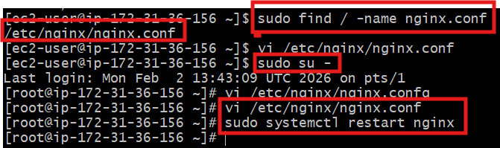
Aftet that I find the file loction
After that I change it to root user
And I edit the that file
And I edit listen numbers to 81

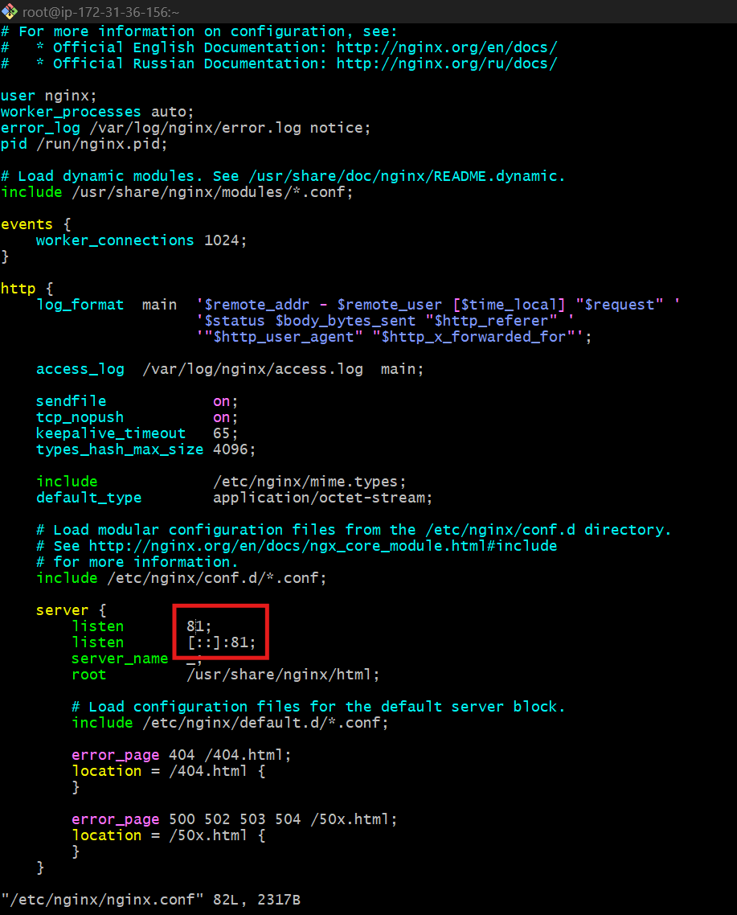
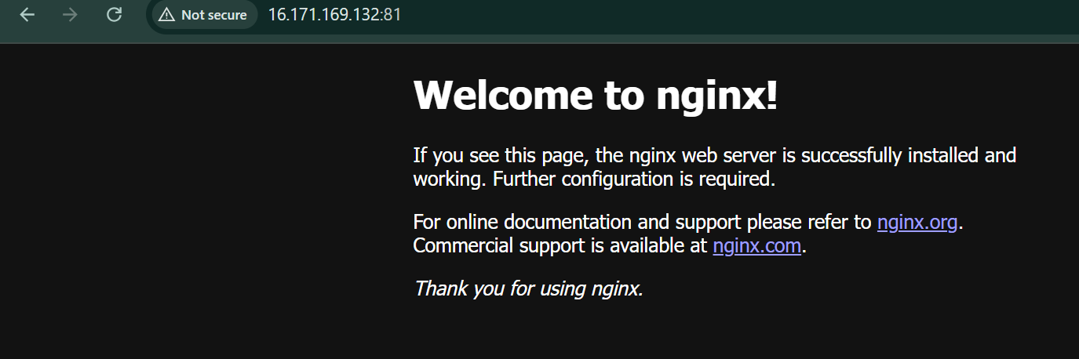\
Yeah its done iam sussefully run the port to 81

2 Deploy a sample index.html file on nginx

Go to Nginx Web Root Directory
cd /usr/share/nginx/html
ls
Create New Sample index.html
sudo vi index.html
<!DOCTYPE html>
<html>
<head>
<title>Hello this is abhinay</title>
</head>
<body>
<h1>thank you</h1>
<p>Deployed Successfully on Port 81</p>
</body>
</html>
ESC → :wq → Enter
Set Proper Permissions
sudo chmod 644 index.html
sudo systemctl restart nginx

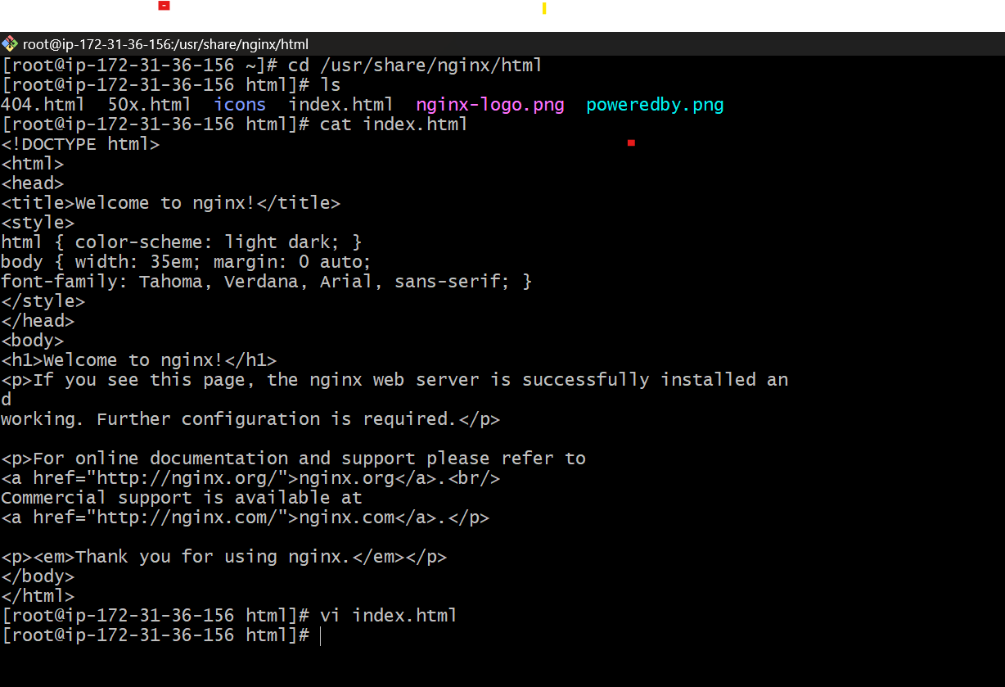
Test in Browser by using public ip
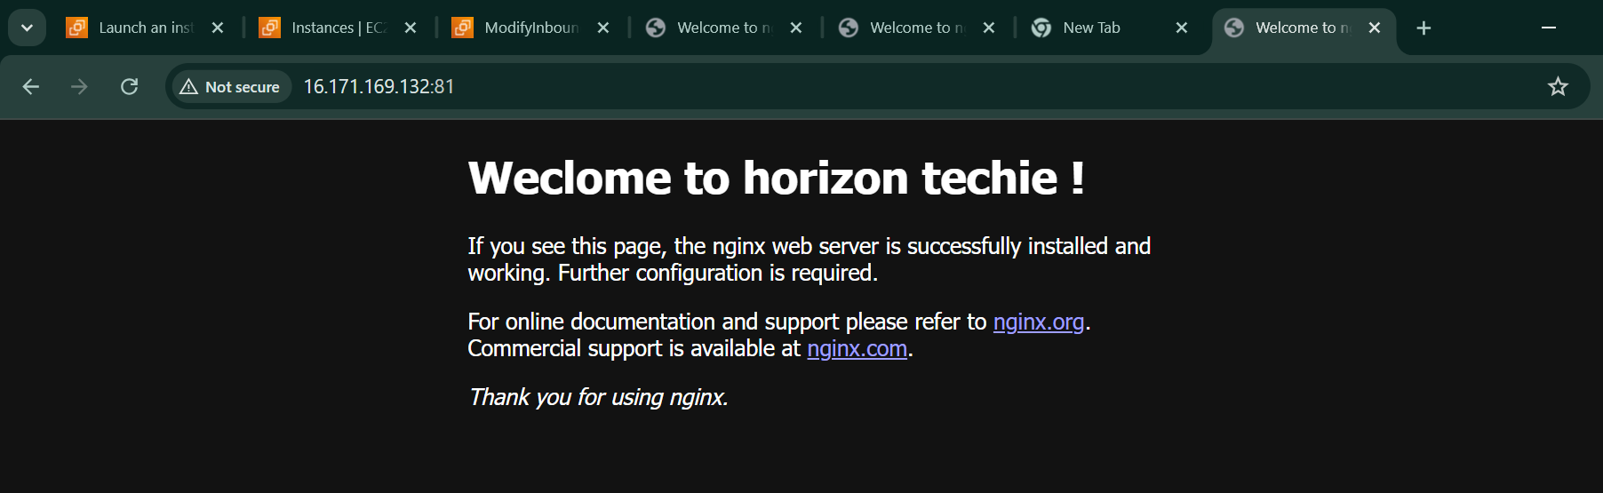
3 Install Apache and run Apache on port number 82

insrtall Apache
sudo yum install httpd -y
sudo systemctl start httpd
sudo systemctl enable httpd
sudo systemctl status httpd
check in browser by using public id and then we continue to change port number
Change Apache Port to 82
sudo vi /etc/httpd/conf/httpd.conf
Find:
Listen 80
Change to:
Listen 82
And do some changes in AWS
Add inbound rules in security group (add port no:82)
Restart Apache
sudo systemctl restart httpd
sudo netstat -na | grep httpd

and run a browser
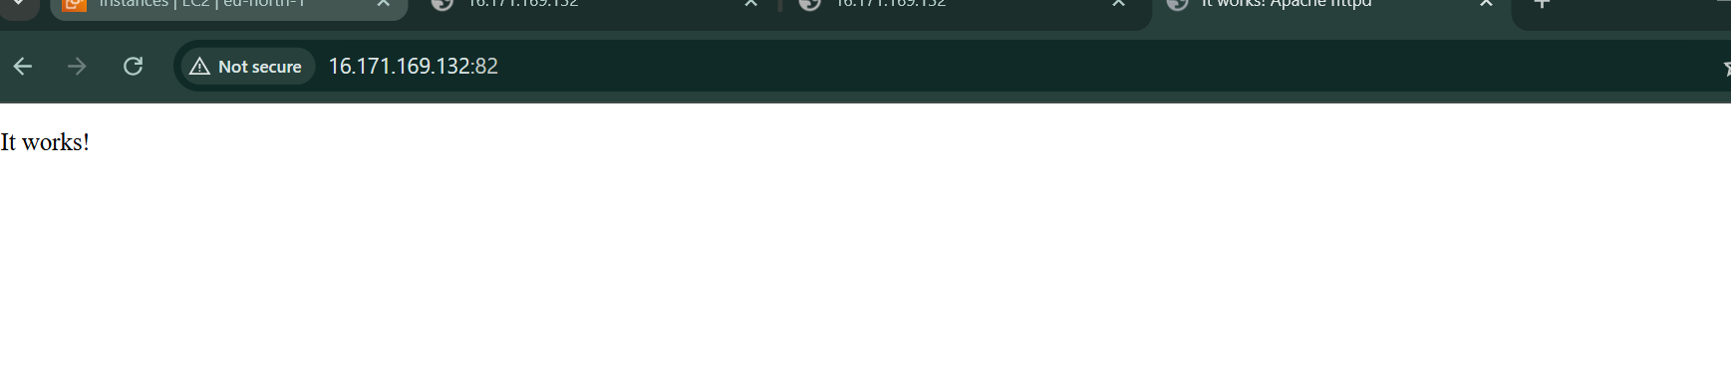

4 Deploy a sample index.html file on Apache.
To Deploy the index tml on apache

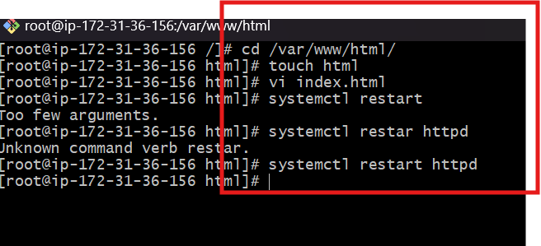

Browse with ip


- Install Apache tomcat on port number 8082
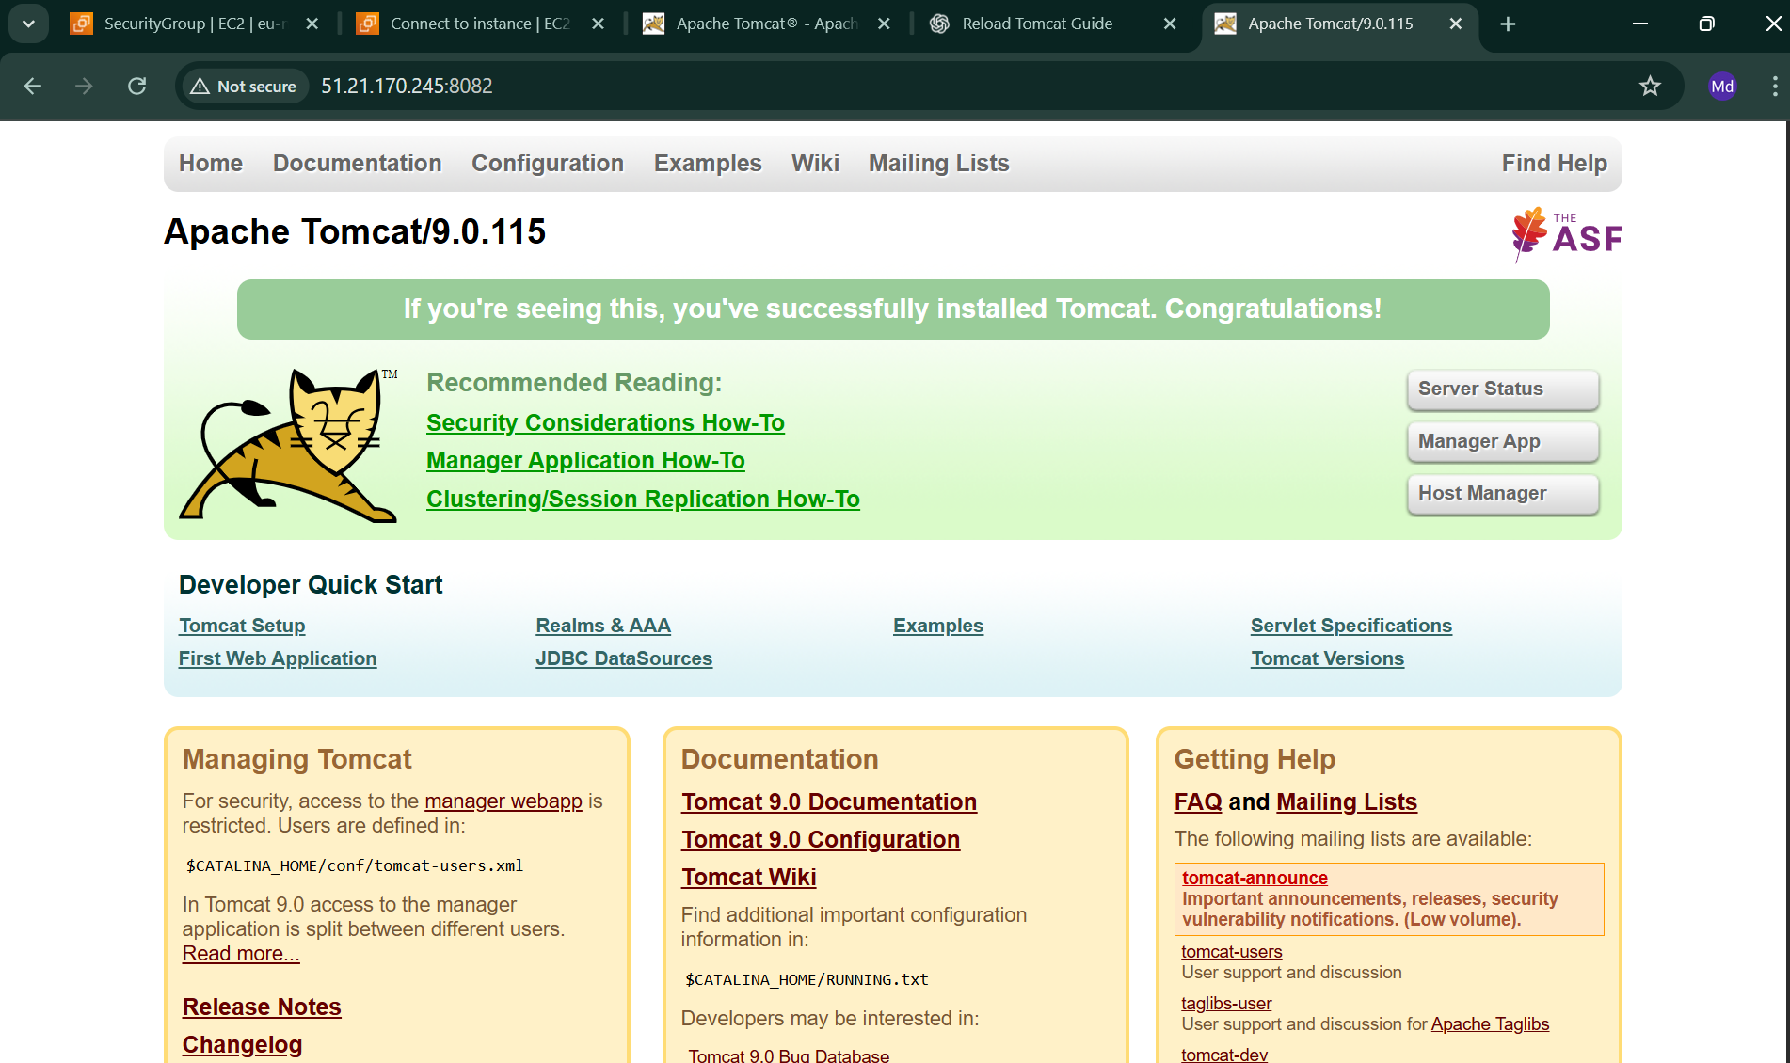

- Deploy a sample app on webapps?
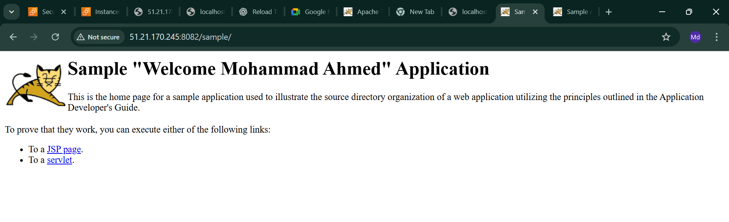
7 Create a tomcat.service file for tomcat.?

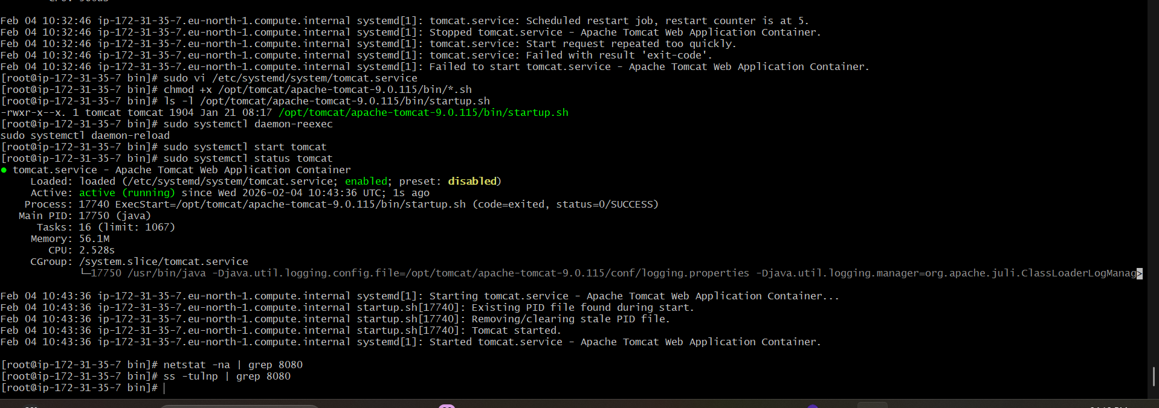

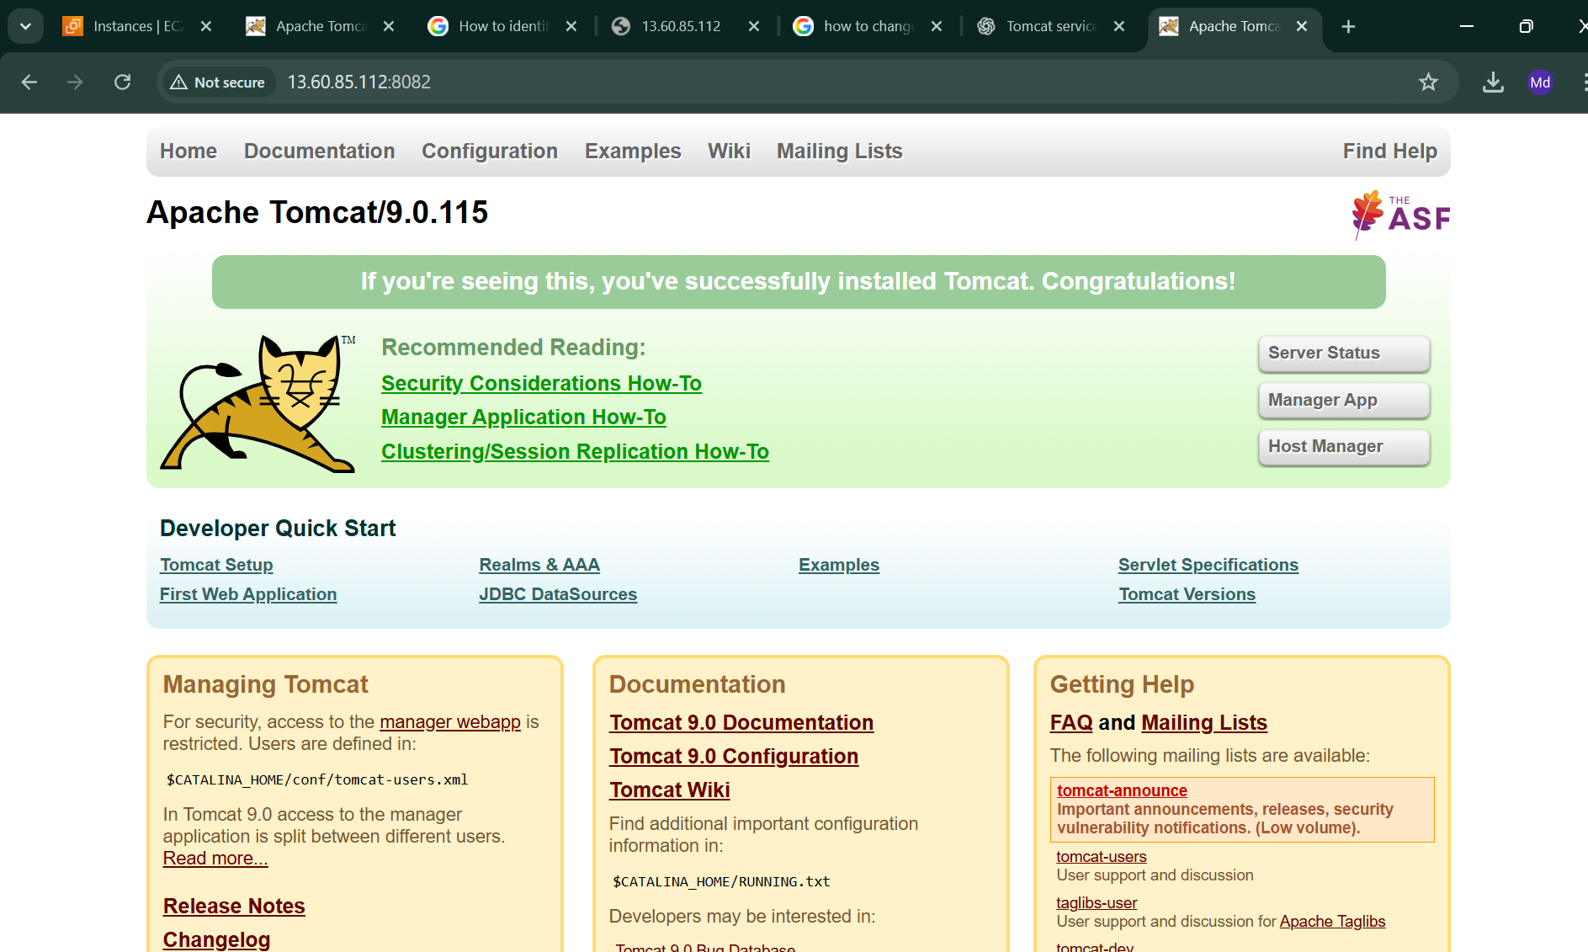

8 Configure HA Proxy server

